Flow Control

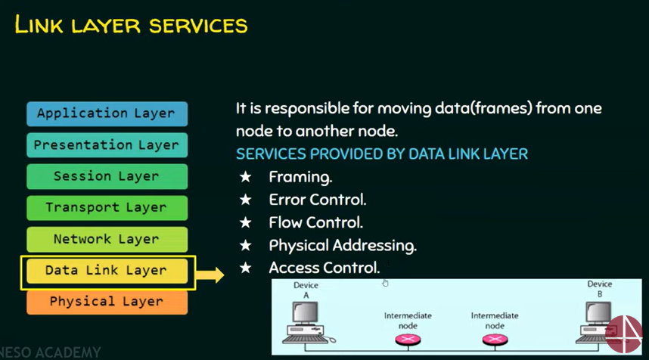

1. Speed matching mechanism
2. Flow control coordinates the amount of data that can be sent before receiving an acknowledgement
3. Flow control is a set of procedures that tells the sender how much data it can transmit before it must wait for an acknowledgement from the receiver.
4. Receiver has a limited speed at which it can process incoming data and a limited amount of memory in which to store incoming data.
5. Receiver must inform the sender before the limits are reached and request that the transmitter to send fewer frames or stop temporarily.
6. Flow control - protocols
   1. Noiseless Channels
      1. Simplest
      2. Stop-and-wait
   2. Noisy channels
      1. Stop -and-wait ARQ
      2. Go-Back-N-ARQ
      3. Selective repeat ARQ